PDPC Singapore Compliance for Log360
Strengthen data protection and meet PDPC Singapore compliance with Log360.
Region: Singapore | Type: Data Privacy, Government/Public Sector | Category: Compliance | Pricing: Free

Overview
The PDPC Singapore compliance extension in Log360 helps organizations meet the Personal Data Protection Act 2012 (PDPA, Singapore), Singapore's primary data protection legislation enforced by the PDPC for private and public sector organizations by providing centralized log management, real-time data access monitoring, and behavioral threat analytics. The platform supports PDPC Singapore requirements for consent enforcement, protection obligations, data breach detection, privileged access control, retention limitation, cross-border transfer monitoring, audit logging, and accountability.
For Consent and Purpose Limitation Obligation, Log360 monitors logon and access events across Windows, Unix, and cloud environments to detect unauthorized or out-of-scope data access violating consent and purpose. To address Protection Obligation (Security Arrangements), the platform monitors file access, database operations, and user sessions to detect security events compromising personal data repositories and meet. The extension also supports Access and Correction Obligation by providing capabilities that maintains audit trails of user account activities and data modifications, helping organizations locate and document personal data records for access and correction requests.

Key Features
- Access and Correction Obligation: Log360 maintains audit trails of user account activities and data modifications, helping organizations locate and document personal data records for access and correction requests.
- Retention Limitation Obligation: Log360 monitors database audit logs and system events to track data deletion activities and identify retention of personal data beyond required periods, supporting data minimization and retention limitation.
- Transfer Limitation Obligation: Log360 monitors AWS data operations and cloud file transfer events to detect unauthorized cross-border movements of personal data violating PDPA's Transfer.
- Privileged Access and Administrative Controls: Log360 records elevated privilege operations, policy changes, and role management events across Active Directory, Unix, and cloud platforms to detect.

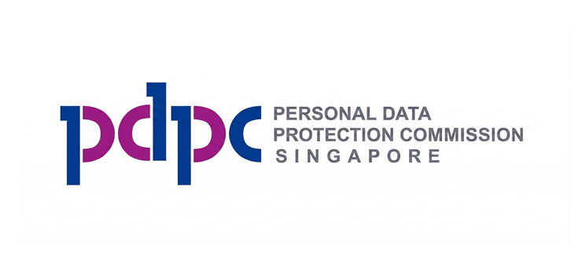
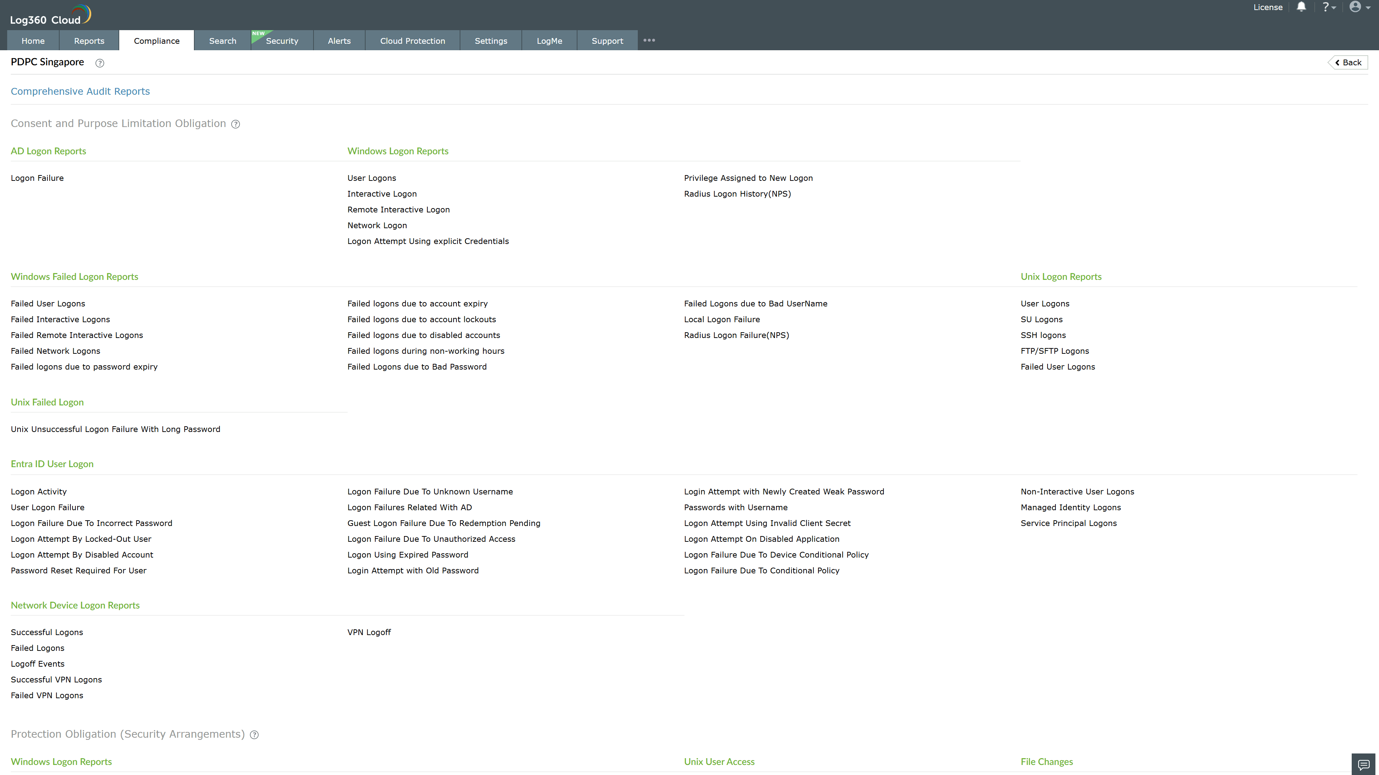
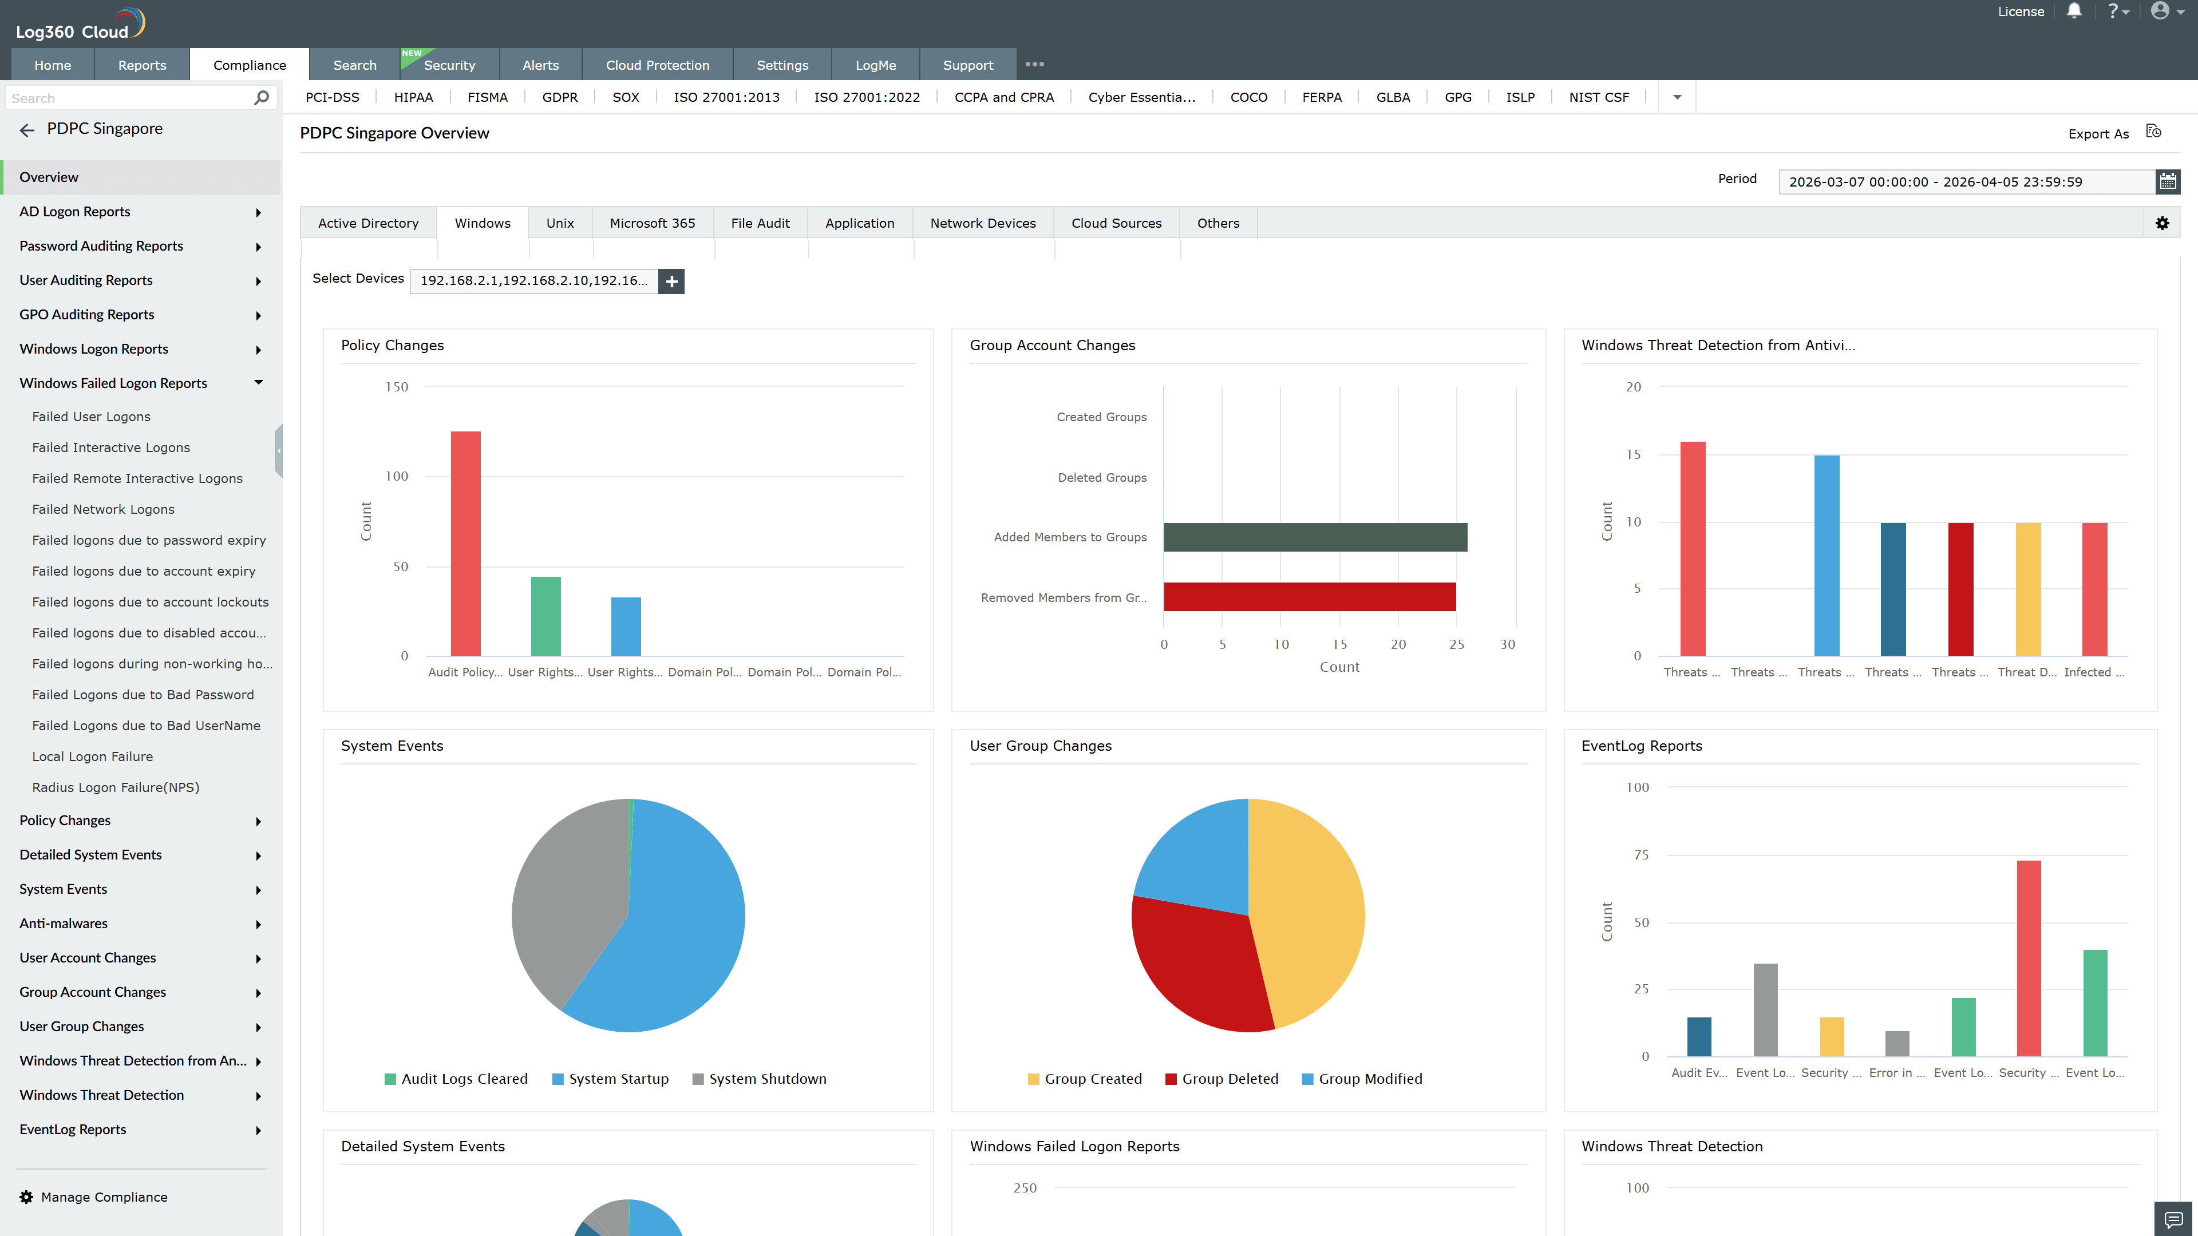
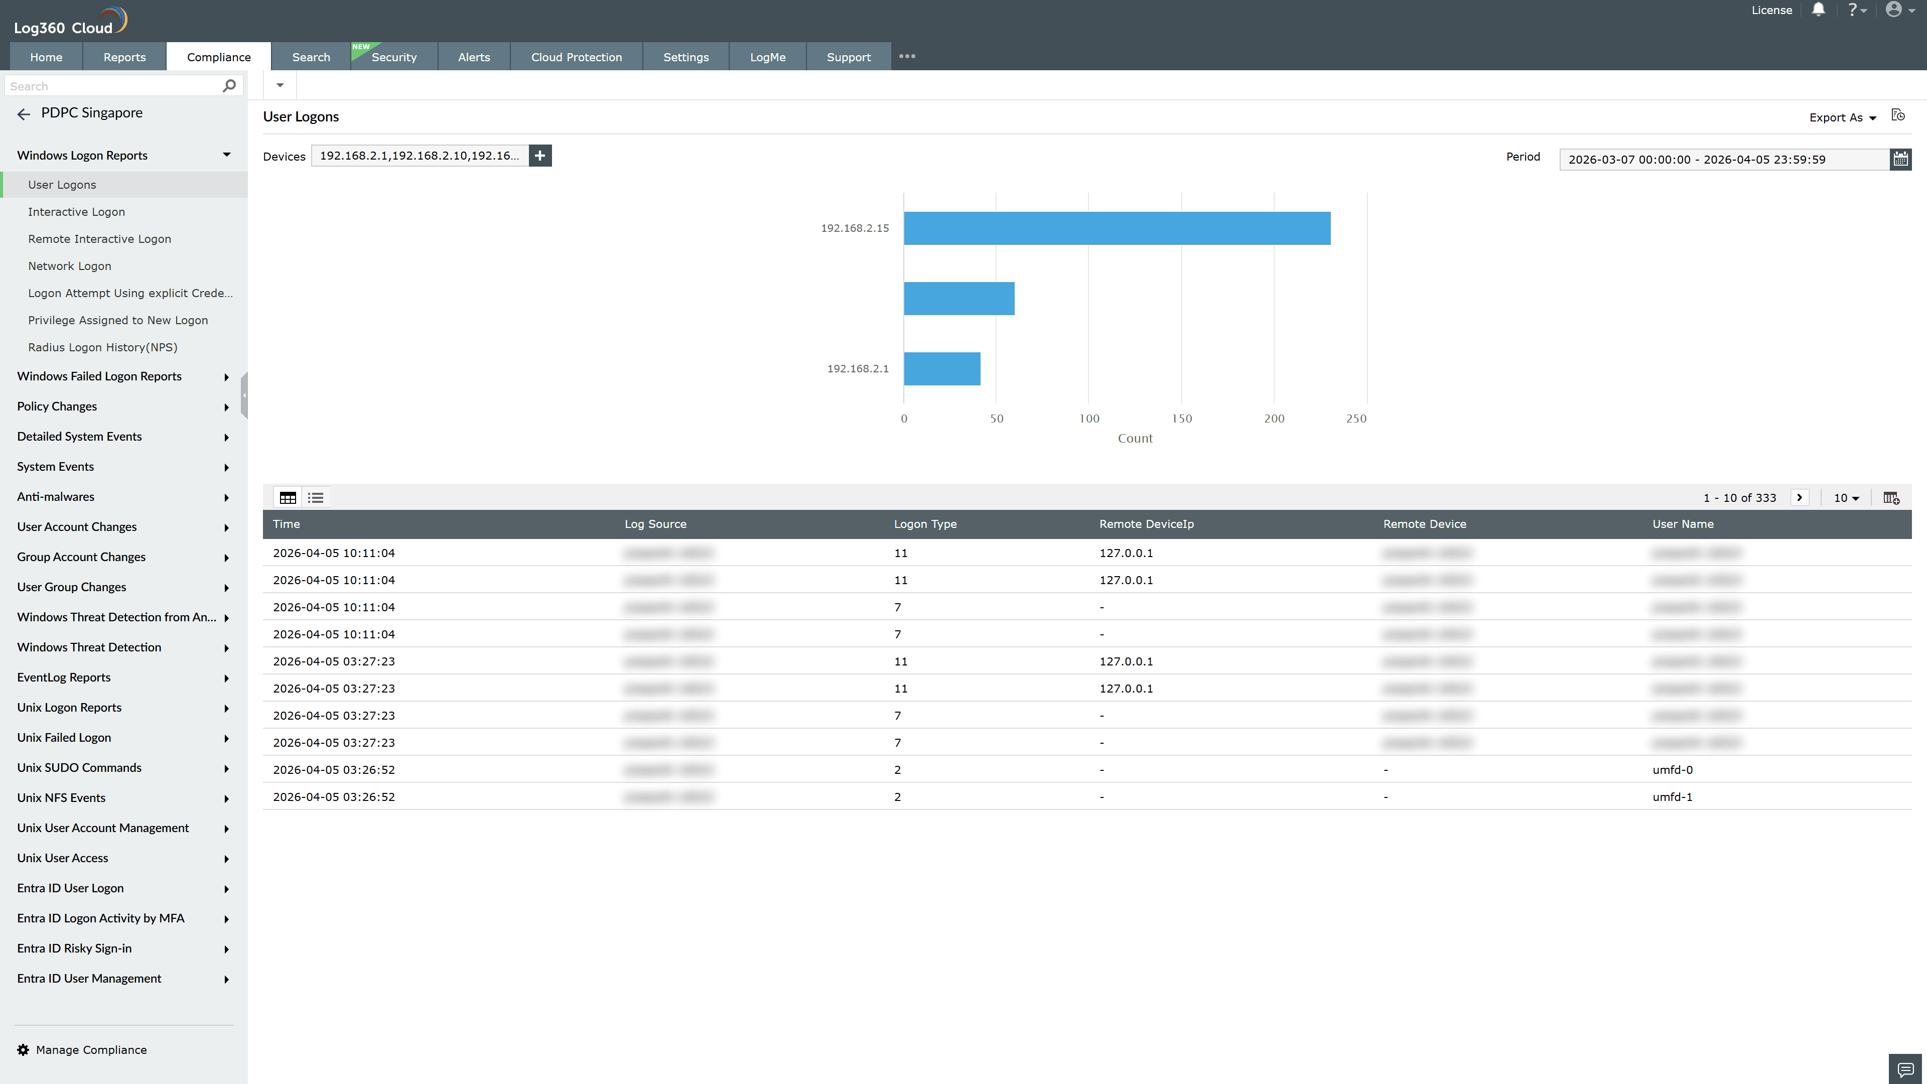
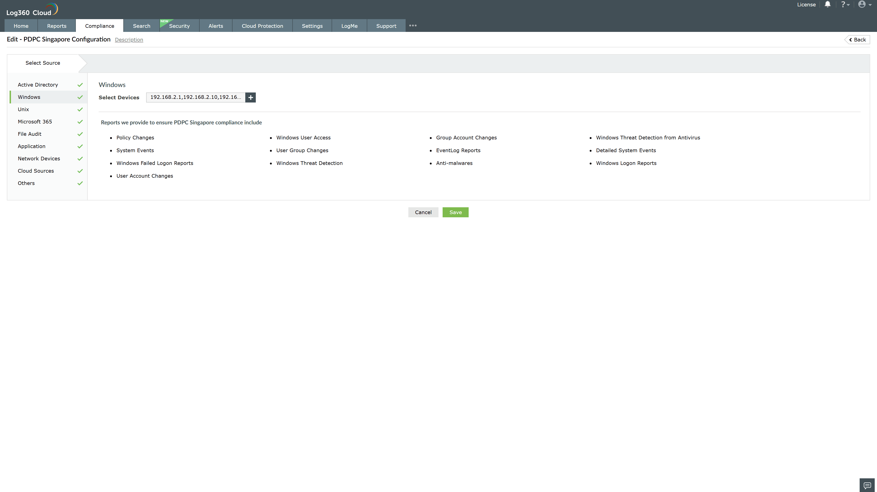
Valid Submission : Yes
Supported Editions : Free, Basic, Standard, Professional, MSSP
Help Document : https://www.manageengine.com/log-management/help/integrations/compliance-extensions.html
Help Video : Not provided
Tags : Log360, Compliance, Privacy monitoring, Data privacy, Regulatory compliance
Supported DCs : US, IN, JP, CA, AU, UK and EU
Privacy Policy:
Terms of Service:
Release Notes:
Predefined reports for the PDPC Singapore.

